Civil war in Somalia

UNSC Resolution: | 751
Date of adoption: | 24-Apr-1992
Operative paragraph: | 14
Demand number: | 751,1411

Sarah-Myriam Martin-Brûlé

Wording of demand
- facilitate the efforts of the United Nations, its specialized agencies and humanitarian organizations to provide urgent humanitarian assistance to the affected population in Somalia, and full respect for the security and safety of the personnel of the humanitarian organizations and the guarantee of their complete freedom of movement in and around Mogadishu and other parts of Somalia

List of addressees of the demand

Government of Somalia, United Somali Congress Faction

Short-term compliance

Description of the addressee(s)’ conduct

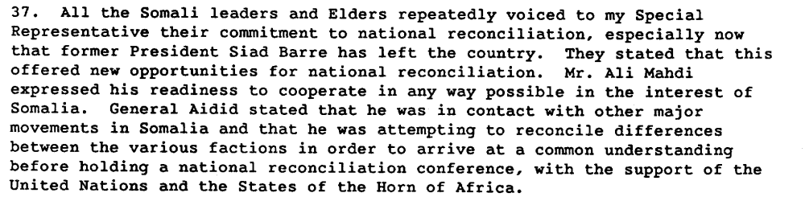

Report of the Secretary General on the Situation in Somalia, S 24343, 22 July 1992.

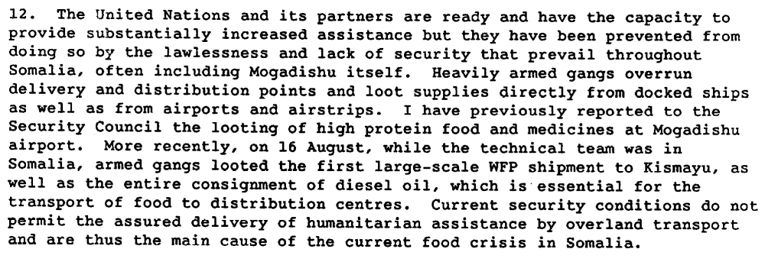

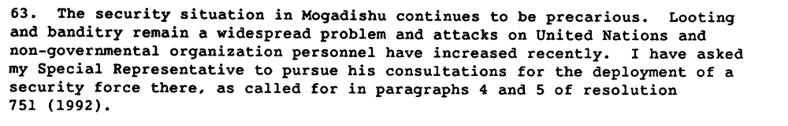

Report of the Secretary General on the Situation in Somalia, S 24343, 22 July 1992.

“ Despite the agreement, local militias continued to pressure UN staff and the Pakistanis for payments of NGO relief flight and airport fees. (…) The Mogadishu airport situation was symbolic of the chaos reigning in other parts of the city. The following day, Somali gunmen killed four CARE Somali employees while ambushing CARE humanitarian trucks carrying wheat from Mogadishu to the southern city of Baydhabo, which was hard hit by starvation. Of the thirty-four trucks in the convoy, one one reached Baydhabo.”

Rutherford, Kenneth. Humanitarianism Under Fire : The US and UN Intervention in Somalia. Kumarian Press. p. 69.

“Mogadishu’s harbor, controlled by a mix of militias, including Aidid’s, was the key to getting the quantities of food required to feed the starving population.

“With the harbor the key to the distribution effort, on November 14, Aidid escorted Johntsont on a toru of the dock facilities to discuss potential improvements. Upon first glance, Johnston was stunned by the lackadaisical labor force, which further hindered the humanitarian relief effort. (…) During the harbor visit, artillery fire targeting the docking facilities came from the Mahdi position. (..) three shells fired by Mahdi,s forces had hit a relief ship carrying eleven tons of wheat (…).
The same evening (..) the Pakistani troops came under attack from Aidid’s forces.
The sounds of shelling created pandemonium among international NGO personnel, who scrambled from their residence and offices and used their radios to call the Pakistanis for protection. Too busy trying to protect themselves from Aidid’s forces, the Pakistanis were unable to help.’

Rutherford, Kenneth. Humanitarianism Under Fire : The US and UN Intervention in Somalia. Kumarian Press. p. 70

Assessment

Short-term compliance
X No or marginal compliance (1) | Medium low compliance (2) | Medium high compliance (3) | Full or almost full compliance (4)

Considerations underlying the assessment

Within the six months following the adoption of the resolution, the demand addressees did not facilitate the efforts of the United Nations, its specialized agencies and humanitarian organizations to provide urgent humanitarian assistance to the affected population in Somalia. They did not respect for the security and safety of the personnel of the humanitarian organizations and did not guarantee of their complete freedom of movement in and around Mogadishu and other parts of Somalia.

Medium-term compliance

Description of the addressee(s)’ conduct
“The meetings all ended with the same conclusion about Somalia: militias and their warlord leaders would not work with peacekeepers to facilitate food deliveries. In fact, the militias would continue to loot the humanitarian aid unless faced with forceful opposition’

Rutherford, Kenneth. Humanitarianism Under Fire : The US and UN Intervention in Somalia. Kumarian Press. p.71.

“The looting and extortion, including far-reaching protection rackets, continued after the air lifts began, and even intensified. The relief organizations did the best they could under the circumstances. They hired armed security guards, a method virtually unheard of in other disaster situations. In some cases, such protection had to be bought from the same sources that had created the intimidation and insecurity, as the following case makes clear.
Dr. Mohamed Ali Warsame, a gynecologist and one of the best-known doctors in Somalia, went missing and was probably murdered in Mogadishu in November 1992. It is believed that Dr. Warsame was killed because he was a Darod, and as a prominent doctor aroused the envy and anger of Hawiye doctors affiliated with General Aideed's wing of the USC.

Paradoxically, the increased security for those delivering humanitarian services has resulted in more insecurity for others in Somalia. With relief supplies no longer easy picking, thugs and looters, be they under the control of organized forces or acting on their own, have turned to other targets for theft and extortion. Foreign journalists have been victimized repeatedly. The insecurity for Somalis is probably greater, although it is rarely makes the international press. This transferred insecurity is a particular problem in Mogadishu, because the city is large and it is not possible to secure most of its quarters. Adding to that problem is that the conflict between rival factions of the USC remains unresolved, and the cease-fire that such forces observe is at best precarious. In Kismayu and Bardera, where there is a strong international presence, the insecurity is even more closely related to the unsettled political violence

Throughout 1992, the ICRC and other relief organizations struggled desperately to meet Somalia's massive humanitarian needs, while increasing insecurity impeded their operations. On January 5, 1992, Dr. Martinka Pumpalova, a Bulgarian doctor working with UNICEF in the northeastern city of Bosaso, was murdered. Some organizations pulled out temporarily as a result. For those that stayed, security conditions deteriorated to the point that they took the unprecedented step of hiring security guards to protect the delivery of their services. The following case exemplifies both the dangers to relief operations and the impunity enjoyed by thugs under the command of warlords.”

Human Rights Watch. 1993.SOMALIA :Beyond the Warlords The Need for a Verdict on Human Rights Abuses March 7, 1993 Vol. V, Issue No. 2
http://www.hrw.org/legacy/reports/1993/somalia/

Assessment

Medium-term compliance
X No or marginal compliance (1) | Medium low compliance (2) | Medium high compliance (3) | Full or almost full compliance (4)

Considerations underlying the assessment

There was no compliance in the medium-term. If the parties agreed with the initial deployment of troops, they continued the attacks and the looting of humanitarian material.

Depth of demand

Assessment

Level of depth of demand
Low depth of demand (1) | X Medium depth of demand (2) | High depth of demand (3)

Considerations underlying the assessment
Looting was a way for the demand addressees to gain revenues/power. Compliance with this demand made it more for the demand addressees to attain victory in the civil war or to win power in its aftermath.

“Historical experience— the competitive rent-seeking of the Somali Republic and the open kleptocracy of the Barre dictatorship—has taught the Somalis that government is primarily a tool of economic gain for those in power.45 It is for this reason that fighting in Mogadishu has been so fierce: control over the capital is essential to establish a credible claim to the entire country’s government. The warlords have extended their depredations to other areas of southern Somalia to the extent that control of these areas yields resources that can be used in the battle over Mogadishu. Thus, Aideed’s forces have time and again threatened and captured the major port of Kismayo, with its lucrative trade. The farmlands of the Rahanweyn have been expropriated to pay off soldiers in the warlords’ armies. Control of strategic roads, air strips, and harbors has been hotly contested”

Sorens, Jason P. And Leonard Wantchekon. Social Order without the State: The Case of Somalia
http://www.somali-jna.org/downloads/Social%20Order%20without%20the%20State%20Somalis.pdf

Level of confidence about coding decisions

Level of confidence about coding decision
Extremely high | X High | Moderate

Comments to IPI (if any)

“UN emergency relief teams began arriving in Somalia in March 1992, but for the months that followed the NGOs were much more active in the country than was the UN (Sahnoun 1997, 308-09). UN aid fell far short of official targets; moreover, UN operations were centered almost exclusively on Mogadishu (Sahnoun 1997, 310). The concentration of aid in Mogadishu actually exacerbated violent competition in that area (Farah and Lewis 1997, 323). The reason the UN gave for its delay was the security situation. Although some peacekeepers were deployed during 1992, it was not until the U.S. announced in November that it would be sending a large contingent that Somalia saw a significant UN military presence.”
Sorens, Jason P. And Leonard Wantchekon. Social Order without the State: The Case of Somalia
http://www.somali-jna.org/downloads/Social%20Order%20without%20the%20State%20Somalis.pdf

